|  |  |  |  |  |  |
| --- | --- | --- | --- | --- | --- |
| **Group Statistics** | | | | | |
|  | ALGORITHM | N | Mean | Std. Deviation | Std. Error Mean |
| ACCURACY | XG BOOST | 10 | 93.60 | .843 | .267 |
| RF | 10 | 90.80 | 8.230 | 2.603 |

|  |  |  |  |  |  |  |  |  |  |  |  |
| --- | --- | --- | --- | --- | --- | --- | --- | --- | --- | --- | --- |
| **Independent Samples Test** | | | | | | | | | | | |
|  | | Levene's Test for Equality of Variances | | t-test for Equality of Means | | | | | | | |
| F | Sig. | t | df | Sig. (2-tailed) | Mean Difference | Std. Error Difference | 95% Confidence Interval of the Difference | |
| Lower | Upper |
| ACCURACY | Equal variances assumed | 31.448 | .000 | 1.070 | 18 | .030 | 2.800 | 2.616 | -2.696 | 8.296 |
| Equal variances not assumed |  |  | 1.070 | 9.189 | .031 | 2.800 | 2.616 | -3.100 | 8.700 |

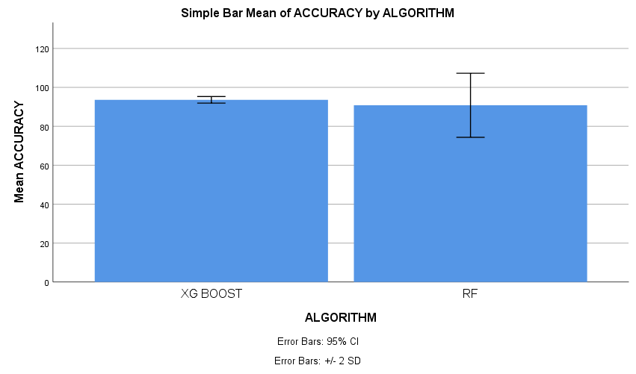

|  |  |  |  |  |  |
| --- | --- | --- | --- | --- | --- |
| **Group Statistics** | | | | | |
|  | ALGORITHM | N | Mean | Std. Deviation | Std. Error Mean |
| ACCURACY | XG BOOST | 10 | 93.60 | .843 | .267 |
| knn | 10 | 74.90 | 3.381 | 1.069 |

|  |  |  |  |  |  |  |  |  |  |  |
| --- | --- | --- | --- | --- | --- | --- | --- | --- | --- | --- |
| **Independent Samples Test** | | | | | | | | | | |
|  | | Levene's Test for Equality of Variances | | t-test for Equality of Means | | | | | | |
| F | Sig. | t | df | Sig. (2-tailed) | Mean Difference | Std. Error Difference | 95% Confidence Interval of the Difference | |
| Lower | Upper |
| ACCURACY | Equal variances assumed | 7.753 | .012 | 16.969 | 18 | .000 | 18.700 | 1.102 | 16.385 | 21.015 |
| Equal variances not assumed |  |  | 16.969 | 10.115 | .000 | 18.700 | 1.102 | 16.248 | 21.152 |

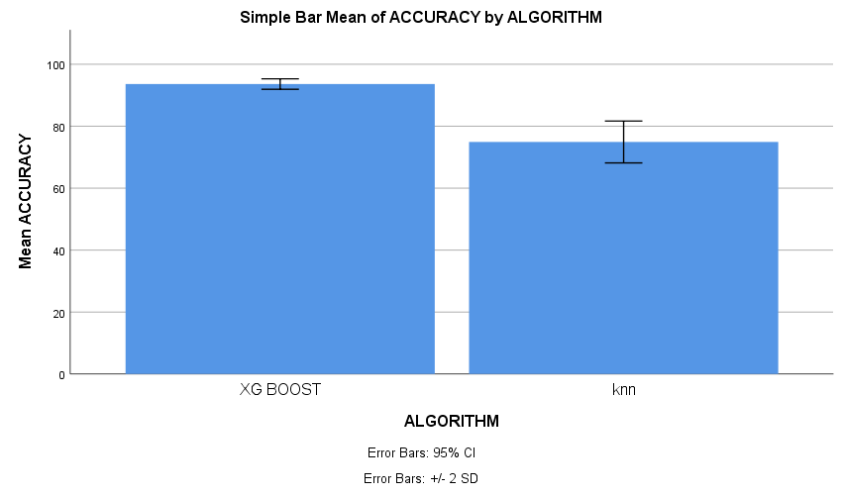

|  |  |  |  |  |  |
| --- | --- | --- | --- | --- | --- |
| **Group Statistics** | | | | | |
|  | ALGORITHM | N | Mean | Std. Deviation | Std. Error Mean |
| ACCURACY | XG BOOST | 10 | 93.60 | .843 | .267 |
| ET | 10 | 83.50 | 5.061 | 1.600 |

|  |  |  |  |  |  |  |  |  |  |  |  |
| --- | --- | --- | --- | --- | --- | --- | --- | --- | --- | --- | --- |
| **Independent Samples Test** | | | | | | | | | | | |
|  | | Levene's Test for Equality of Variances | | t-test for Equality of Means | | | | | | | |
| F | Sig. | t | df | Sig. (2-tailed) | Mean Difference | Std. Error Difference | 95% Confidence Interval of the Difference | |
| Lower | Upper |
| ACCURACY | Equal variances assumed | 9.970 | .005 | 6.225 | 18 | .007 | 10.100 | 1.622 | 6.691 | 13.509 |
| Equal variances not assumed |  |  | 6.225 | 9.499 | .002 | 10.100 | 1.622 | 6.459 | 13.741 |

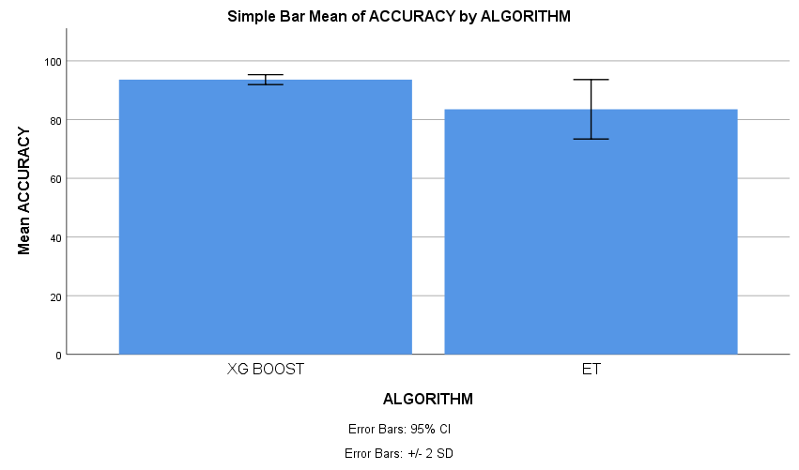

|  |  |  |  |  |  |
| --- | --- | --- | --- | --- | --- |
| **Group Statistics** | | | | | |
|  | ALGORITHM | N | Mean | Std. Deviation | Std. Error Mean |
| ACCURACY | XG BOOST | 10 | 93.60 | .843 | .267 |
| SVM | 10 | 87.70 | 2.263 | .716 |

|  |  |  |  |  |  |  |  |  |  |  |  |
| --- | --- | --- | --- | --- | --- | --- | --- | --- | --- | --- | --- |
| **Independent Samples Test** | | | | | | | | | | | |
|  | | | | | | | | | | | |
|  | | Levene's Test for Equality of Variances | | t-test for Equality of Means | | | | | | | |
| F | Sig. | t | df | Sig. (2-tailed) | Mean Difference | Std. Error Difference | 95% Confidence Interval of the Difference | |
| Lower | Upper |
| ACCURACY | Equal variances assumed | 3.953 | .042 | 7.725 | 18 | .040 | 5.900 | .764 | 4.295 | 7.505 |
| Equal variances not assumed |  |  | 7.725 | 11.452 | .043 | 5.900 | .764 | 4.227 | 7.573 |

